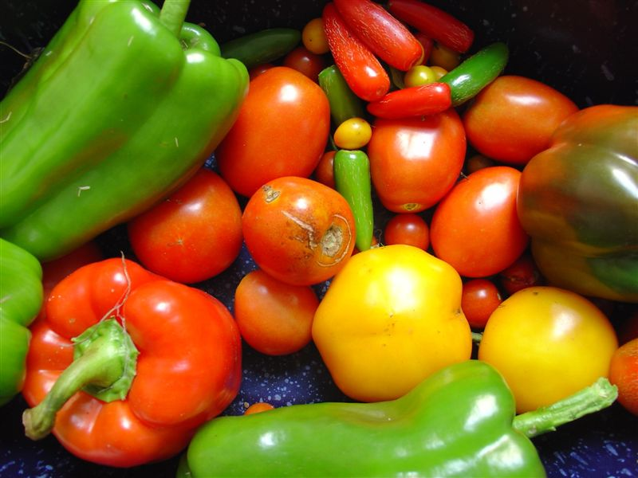

Hands-On Exercise:

Small Scale Production Audit

Factors of Small-Scale Production Support Systems
How is this exercise structured?

- The Audit provides an evaluation tool of 38 specific indicators that will help community leadership determine where they fall on a spectrum of support for local small-scale producers and more importantly, where efforts can be made to strengthen that support.
- The Audit is divided into seven factors (placed-based, government policy/regulations, financial capital, social capital, education and training, culture, and human capital/workforce).
- For each of the 39 indicators, individual scoring ranges have been provided that weigh the indicator in relation to all other indicators. In some instances, the top score will be a 9 and in others a 5.

Place-Based Factors
How would you rate the number of new small-scale startups in the past three years?
Low
High
Moderate
9
7
5
3
1
Your Score
Does your district have dedicated start-up space for emerging small-scale producers such as an incubator, accelerator, shared-kitchen, maker space, etc.?
No or Weak
Strong
Limited
9
7
5
3
1
Your Score

Is your organization engaged with local arts, engineering, or other creative organizations near your community?
No or Seldom
Regularly
Occasionally
5
4
3
2
1
Your Score
Does your university or community college offer their labs, equipment, etc for use by the public?
Limited
Strong
Moderate
9
7
5
3
1
Your Score

Is there a diversity of district housing available (workforce, market, condo, apartments, etc)?
No or Little  1 | 3 | Moderate  5 | 6 | Strong  7 | Your Score

Does your district help make connections for small scale producers to any state and/or national Small Scale Programs (eg. Made in…)?
No 1 | 3 | Sometimes  5 | 6 | Yes  7 | Your Score

Does your district operate an entrepreneurship pitch-it and/or "Shark Tank" like contests for new entrepreneurs?

Does your district have a diversity of "Third Spaces" (e.g., Third places can be churches, coffee shops, gyms, hair/nail salons, post offices, bars, beer gardens, bookstores, parks, community centers, and meet-up spaces)?
Does your district offer access to a range of transportation options (e.g., passenger rail, bike lanes, neighborhood sidewalks, recreation trails, transit, cabs/uber/lyft, interstate highway access)?
No  1 | 3 | Sometimes  5 | 6 | Yes  7 | Your Score

Is your district actively engaged in supporting small-scale producer pipelines (e.g., Farmer's Markets, Etsy Vendors, Pop-Ups; Mobile Retailers)?

Does your district have adequate vacant space to accommodate small scale producers?
Artisan/Crafters/Ag Producers – Typically Needing Micro Spaces (400-700 sq.ft.)

Traditional Small Scale Producers Combination of Retail and Production (1,000-3,000 sq.ft.)

Scalable Producers – Regional/National/International Distribution- May Need Larger Production Facility

Does your district contain a “Made in >>>>” store or other stores that feature locally made products?
No or Weak
Strong
Limited
9
7
5
3
1
Your Score
Do existing larger mfg businesses offer their facilities and/or equipment to small-scale manufacturers, breweries, bakeries, etc for production runs?
No  1 | 3 | Sometimes  5 | 6 | Yes  7 | Your Score

Has your district examined the market and identified target small scale producer opportunities that are aligned with your community (assets, anchors, geography, economic strengths)?
No  1 | 3 | Somewhat  5 | 6 | Yes  7 | Your Score

Government Policy / Regulations Factors

Does your city make the permit process easy for new businesses?
Does your city have a cottage industry ordinance that allows for small batch production from a home kitchen?
No  1 | 3 | 5 | 6 | Yes  7 | Your Score

Does current zoning allow for a small-scale manufacturers, breweries, bakeries, etc?
No  1 | 3 | 5 | 6 | Yes  7 | Your Score

Does your city make special allocations for loading zone areas (truck deliveries, etc) that small scale producers may need for raw materials or shipping finished product?
No  1 | 3 | Sometimes  5 | 6 | Yes  7 | Your Score

Does your City and/or other regional Economic Development leadership have any dedicated capacity and resources to the cultivation and growth of small-scale production?

Financial Capital Factors

Does your district offer incentives to drive targeted small scale production investments (e.g., Grants, Micro Loans, Contests, Equipment Grants, etc.)?

Does your district operate a local crowdfunding program for real estate and/or small business investments that might support small scale producers?

Does your district have a group of local angel investors formed or other non-family equity sources available for small scale production?

Does your local banking community offer SBA and any other federal small business development funding tools?
No  1 | 3 | Limited  5 | 6 | Yes  7 | Your Score

Social Capital Factors

Are there district related clubs or networking activities for small scale producers?

Is there an active SCORE Chapter and/or other mentor program operating in your district?
No  1 | 3 | Limited  5 | 6 | Yes  7 | Your Score

Are current manufacturing business owners supportive of small-scale producers through relationship-building, mentorship, referrals, etc.?

Education and Training Factors

Is there local technical assistance available, provided by the public sector, to support small business development (e.g., succession planning; business plan development, financial analysis, feasibility analysis, multi-channel marketing)?

Are Small Business Development Centers and/or other entrepreneurship technical assistance efforts offered in the district?
No  1 | Occasional  3 | Regional  5 | Local (Not in District)  6 | District  7 | Your Score

Is there educational programming to engage with online maker sales, such as Etsy and/or Maker’s Row?
No  1 | Occasional  3 | Regional  5 | Local (Not in District)  6 | District  7 | Your Score

Is there a Manufacturing Extension Partnership program geared toward technical assistance to small scale producers (exporting, logistics, scaling manufacturing, etc)?
No  1 | Occasional  3 | Regional  5 | Local (Not in District)  6 | District  7 | Your Score

Is the local private business service sector actively involved in supporting new businesses (e.g., marketing/social media, design, accounting, legal, contractors, web development, architects, etc.)
No  1 | 3 | Sometimes  5 | 6 | Yes  7 | Your Score

Culture Factors

Does the local media commonly run features and/or articles on local entrepreneurs or small-scale producers?

Is there ample social capital amongst existing and aspiring entrepreneurs? (i.e. – strong networks and a spirit of collaboration, cooperation, and trust amongst existing and aspiring entrepreneurs)
No  1 | 3 | Sometimes  5 | 6 | Yes  7 | Your Score

Are new entrepreneurs actively engaged in civic and other district groups, boards, committees, etc.?
No  1 | 3 | Sometimes  5 | 6 | Yes  7 | Your Score

Human Capital Factors

Does your district have a local college and/or university that offers degree or certificate programs in entrepreneurship?

Does your neighborhood school system offer entrepreneurship programs for area children?
No  1 | 3 | Limited  5 | 6 | Yes  7 | Your Score

Does your workforce development office provide training funds to for small scale producers to find and train workers?
No  1 | 3 | Sometimes  5 | 6 | Yes  7 | Your Score

What percentage of local entrepreneurs are women or minorities?
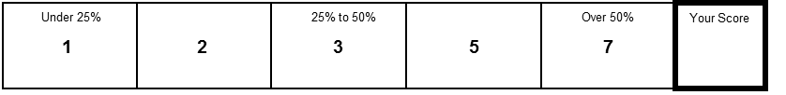

What percentage of local business owners are near or past retirement age?
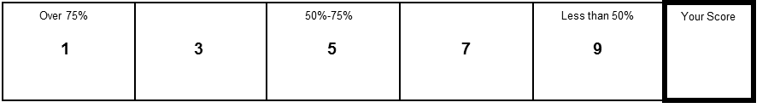

Scoring Your Small Scale Producer Support System Audit

 |  | Minimum Possible Score | Maximum Possible Score
Place-Based Factors Score |  | 16 | 113
Government Policy/Regulations Factors Score |  | 5 | 37
Financial Capital Factors Score |  | 4 | 28
Social Capital Factors Score |  | 3 | 19
Education & Training Factors Score |  | 3 | 21
Culture Factors Score |  | 3 | 21
Human Capital Factors Score |  | 5 | 37
TOTAL SCORE |  | 39 | 276

Evaluating Your Community’s Progress

FOUNDATION STAGE
SCORES BELOW 100
A community in this range is getting organized to support local entrepreneurs and new business startups.

EMERGING STAGE
SCORES ABOVE 100 AND BELOW 175
A community in this range has begun to accumulate the needed assets to create a Small Scale Production Support System.

THRIVING STAGE
SCORES ABOVE 175 AND BELOW 230
A community in this range has a strong Small Scale Production Support System underway.

SUSTAINABLE STAGE
SCORES ABOVE 230
A community in this range has a well-established Small Scale Production Support System that has the strength to maintain a vibrant program over time.

